IT6037 Data Access & Management
Assessment 2
Group: Monke
System Design Document

Contents
Overview 2
Architecture 2
Database Design 3
Entities, Attributes, and Datatype: 3
Relationships: 4
Queries: 5
User Access Design 8
User Experience Design 9

Overview

We as a team are required to create a single-page web application for school students so that they can search for information. This web application will have a database that provides study materials on three subjects: Art, Mathematics, and Technology. We must make sure that the users will have different access permissions depending on their roles such as Administrator, Teacher, and Student.

Architecture

To create our web application, we have a lot of DBMS architectures available for us to use such as PostgreSQL, MongoDB, MySQL, and many more but we decided to stick with SQLite. The reason is because SQLite is already built-into Django which we are planning to use for our web application framework. And compared to other DBMS, SQLite is very simple to use, it doesn’t require a server to keep it running and is great for our web application as it’s not demanding and SQLite is great for smaller to medium data sizes.

As for the reason why, we are planning to use Django as our Python web framework it’s because it provides many benefits that will make building the web application much easier such as providing many built-in securities function that we can use to make our application more robust, it’s pretty simple compared to other frameworks, it may not be the lightest framework but it’s still got a good balance of speed, and many more.

Database Design
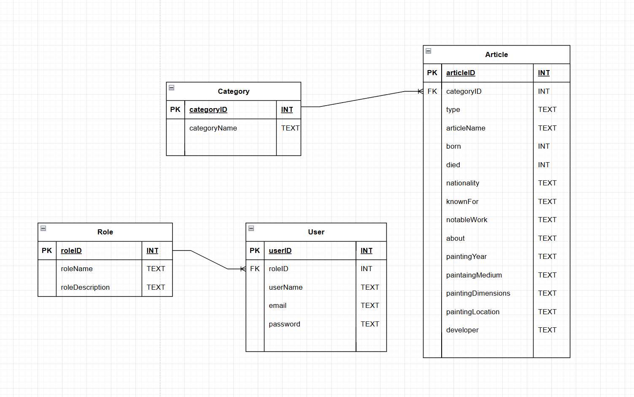

Entities, Attributes, and Datatype:
- Category: This is an Entity that will keep track of different categories of the article by keeping the lists clean and normalizing the database. There will only be two attributes in this entity:
  - PK, categoryID (int): This is the primary key of the entity table, giving unique ID for each category.
  - categoryName (text): This stores the name of the category e.g. Arts
- Articles: This Entity will store all articles, data and information. There are 16 attributes within this entity which are:
  - PK, articleID (int): This is the primary key of the entity table, giving unique ID for each article.
  - FK, categoryID (int): This is foreign key joint from the category table so that we can set what category does the article belong to.
  - Type (text): This attribute will tell what type of article you’re reading about, for example if the article is a biography or a painting, etc.
  - articleName (text): This stores the name of the article.
  - Born (int): This stores information about the year that the author/artist was born on.
  - Died (int): This stores information of the year that the author/artist passed away.
  - Nationality (text): This stores the nationality of the author/artist.
  - knownFor (text): This attribute is to tell what the author/artist is known for in their profession.
  - notableWork (text): This attribute is to tell what work the author/artist is most known for.
  - About (text): This is a description of the article and its main content.
  - paintingYear (int): This is to tell when the painting/drawing was created.
  - paintingMedium (text): This is to tell what medium was the painting drawn with.
  - paintingDimensions (text): This is the size and dimensions of the painting.
  - Developer (text): This is mainly for technology and for who developed them.
- Role: This is an Entity that will keep track of the roles and permissions of the users so that we know what their access levels are. This table has three attributes:
  - PK, roleID (int): This is the primary key of the entity table, giving unique ID for each role.
  - roleName (text): This stores the name of each role group.
  - roleDescription (text): This is to store information of each role such as their permissions.
- User: This is an Entity that will store user data and information. This table has five attributes:
  - PK, userID (int): This is the primary key of the entity table, giving unique ID for each user.
  - FK, roleID (int): This is foreign key joint from the role table so that we can see what role the user belongs to and their permissions.
  - userName (text): This stores the name of the user.
  - Email (text): This stores the email of the user.
  - Password (text): This stores the password of the user.

Relationships:
- Category-Article: One to Many relationships, as one category can contain multiple articles.
- Role-User: One to Many relationships, as one role can contain multiple users.

Queries:

Article Queries
- Browse articles by category
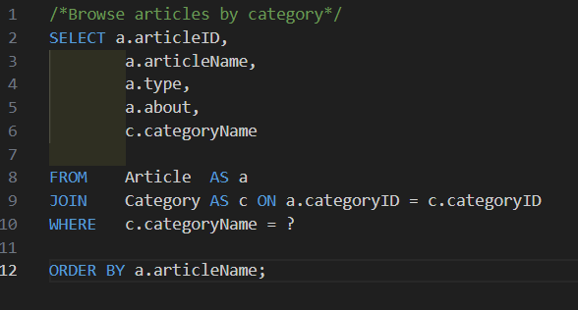
This query returns all articles that belong to a specific category (Art, Mathematics, or Technology). It joins the Article and Category tables so that the system can show the category name together with each article.

- Search articles by keyword in the title
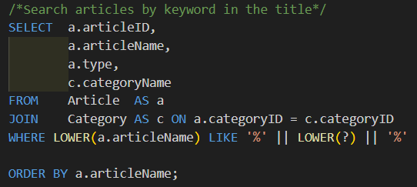
This query searches for articles where the title contains a given keyword. It converts both the article title and the search term to lowercase, letting the search to be case-insensitive.

- List of all articles
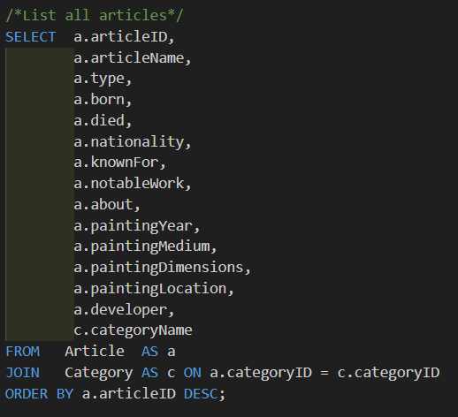
This query retrieves the full article, including all fields. It is to display all the articles for review / easy management.

- Insert a new article
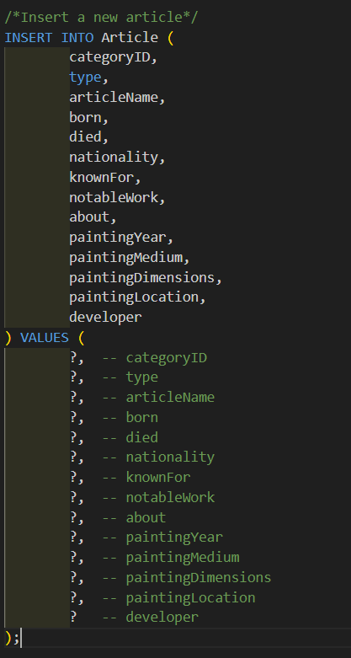
This query adds a new article into the database only used by tutors or admins.

- Update an existing article
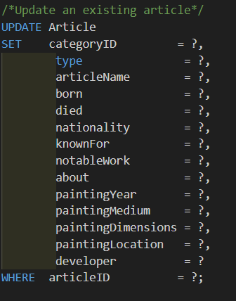
This query updates the details of an existing article. Tutors and admins use this when changing article content.
- Delete an article
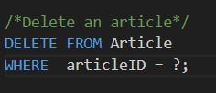
This query removes an article from the database.

Categories Queries
- List all the Categories
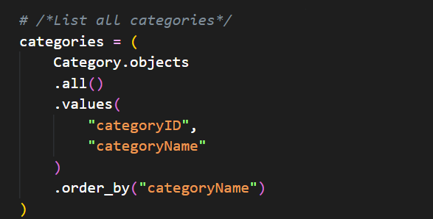

- GET a Category by ID
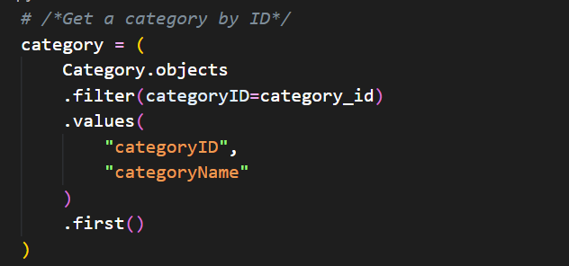

- Search Categories by Name
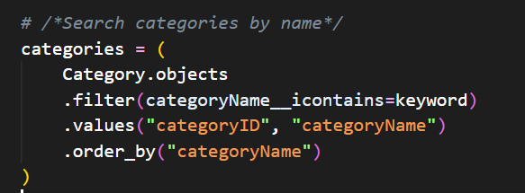
- Insert (Create) a new Category
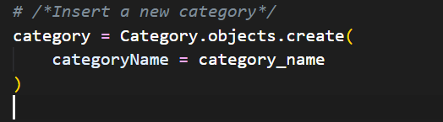
- Update an existing category
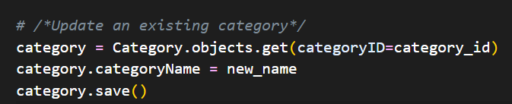

- Delete a category
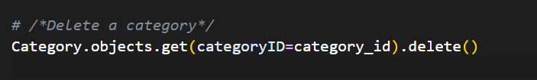

User Queries
- List all the users
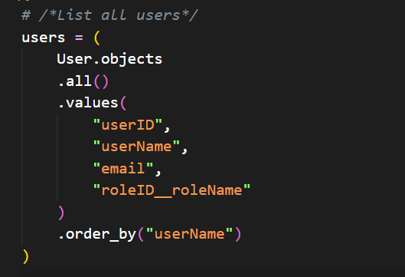

- Get a user by email
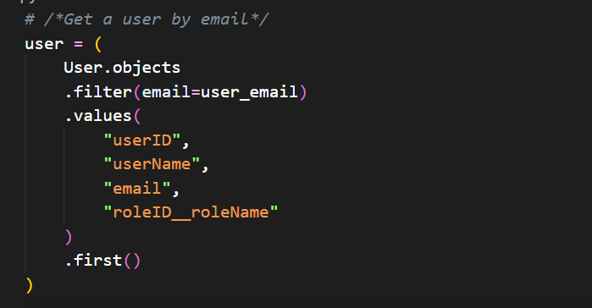
- Get all users by role
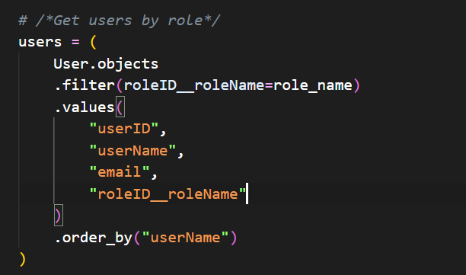
- Insert (Create) a new user
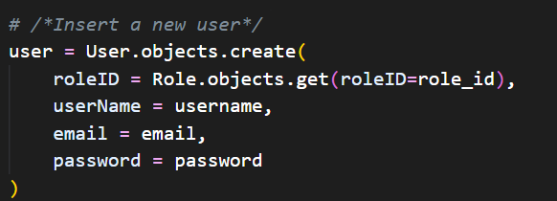
- Update an existing user
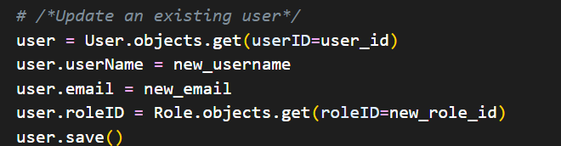
- Delete a user
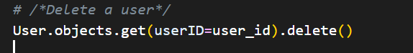

Role Queries
- List all roles
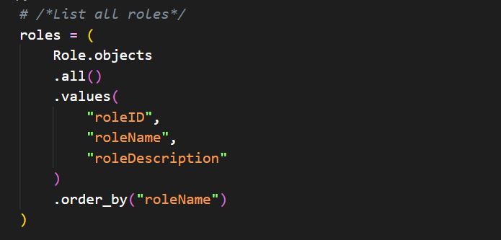
- Get a role by ID
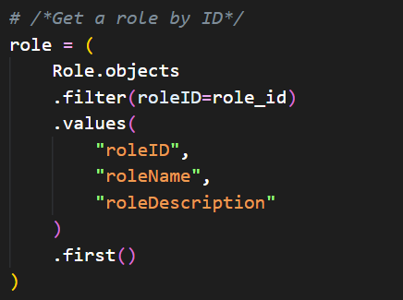
- Insert (create) a new role
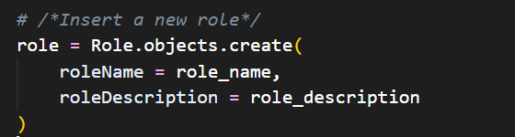
- Update a role
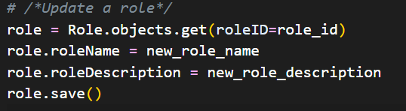
- Delete a role
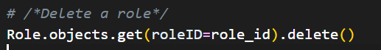

User Access Design

Using Django, we can implement user security through its framework. Django provides a built-in user model, along with the ability to create groups and assign permissions in their built-in UI. This allows us to securely control user access and authorization as we build the application. Here, we can define user roles and permissions which Django enforces.
Students – View articles
Tutors – Create and update articles
Admins – Create, update, and delete articles
Django also enforces centralized authorization in its framework, which maintains security and ensures “workarounds” and bugs to bypass restrictions don’t happen. We have also employed a security compliance and secure code checklist;
Server-side input validation – Handled by Django
Authentication control – Enforced by Django’s groups and permissions
Password Protection – Django automatically hashes passwords to protect them.
Password Strength – Django allows us to enforce strong and secure passwords.
Session Security – Django stores session data and handles session validation server-side, along with enforcing CSRF protection.
Code Protection – Django protects server-side code / python files from the user.
Django uses CSRF protection which validates user requests, and built-in password protection through hashing, algorithms, and password policies we can configure ourselves to ensure user authentication. The framework also allows us to require login and properly enforce permissions to keep users from making unauthorized actions. This allows our application to follow “security-by-design" principles.

User Experience Design

For views, we decided on a single-page application containing a header, search bar, buttons, and the article list/results. We implemented popups to fulfill the login and create/read/update/delete requirements. For design, we implemented simple pattern and layout, to emphasize readability and easy navigation and ease the users’ eyes; allowing students to easily move through articles for their research, and for tutors to refer to them easily.
A header to contain the application name and a login button was used; the login button should bring a popup that lets the user log in with their credentials easily. When logged in, this button will be a logout button for instances where a different user needs to take over. The search bar was implemented for users to further improve user experience. By default, all articles should be displayed, then the All button removes any search filters, displaying every article again.
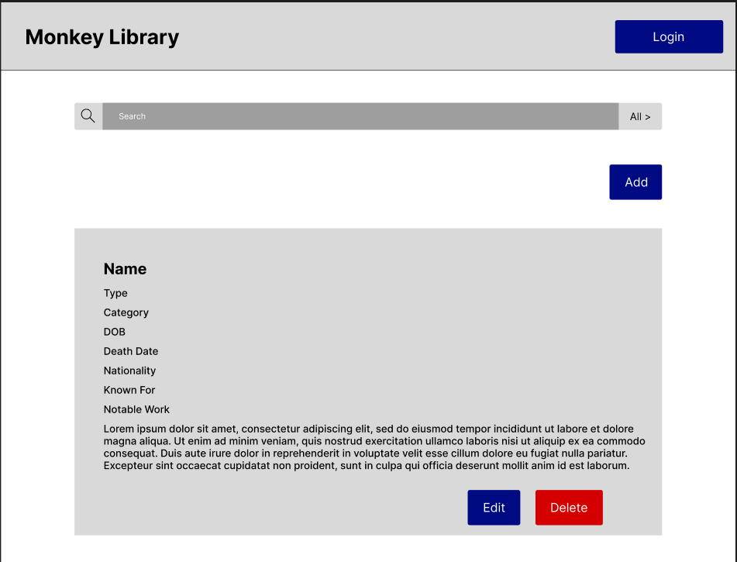
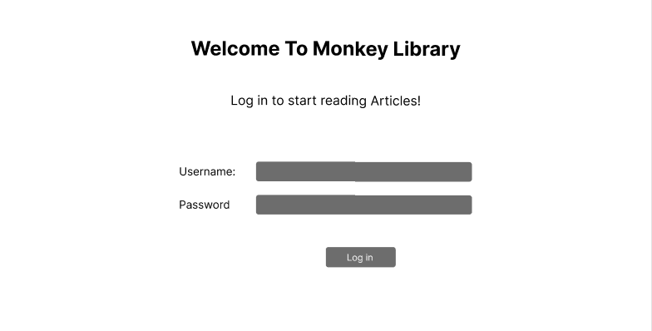
Additionally, a button to give tutors and admins the ability to add articles was placed before the article list, letting them conveniently create new articles. In the articles lsit, all information is displayed, allowing the user to scroll through each article comfortably while still being able to see its content. The edit button is present for tutors and admin; in the instance of an edit, a popup will appear allowing the user to change the article’s information and content. For admins, they will see the delete button; they will receive a popup making sure they wish to delete that article.
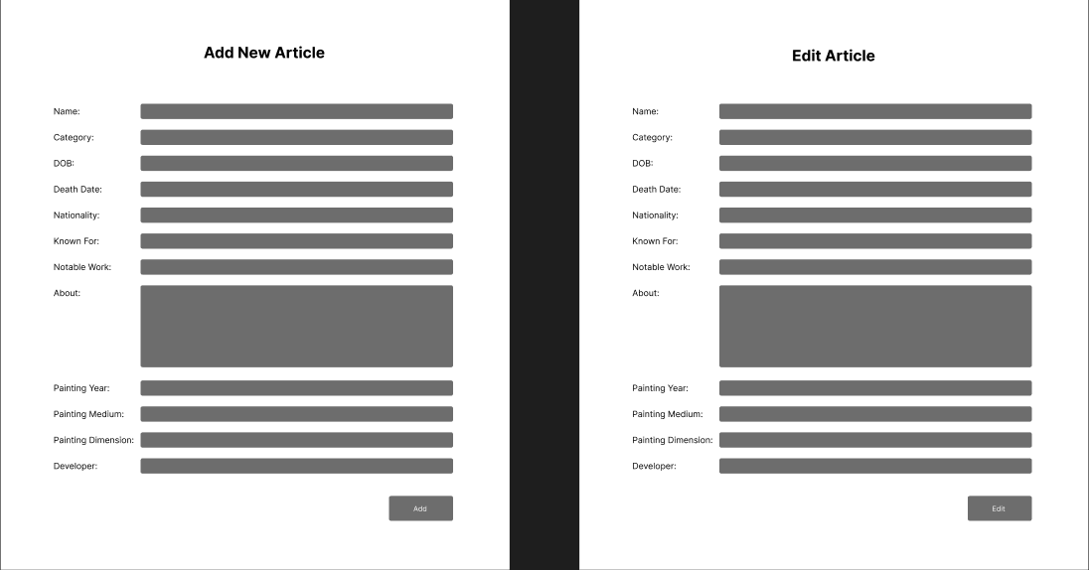
Figma Link: https://www.figma.com/design/yrhxeMVYHCSp7DwgKDHbON/Untitled?node-id=0-1&t=1Y1QIlZJbcbIwHXr-1

